Android SQLite Query SELECT

Query Method 1

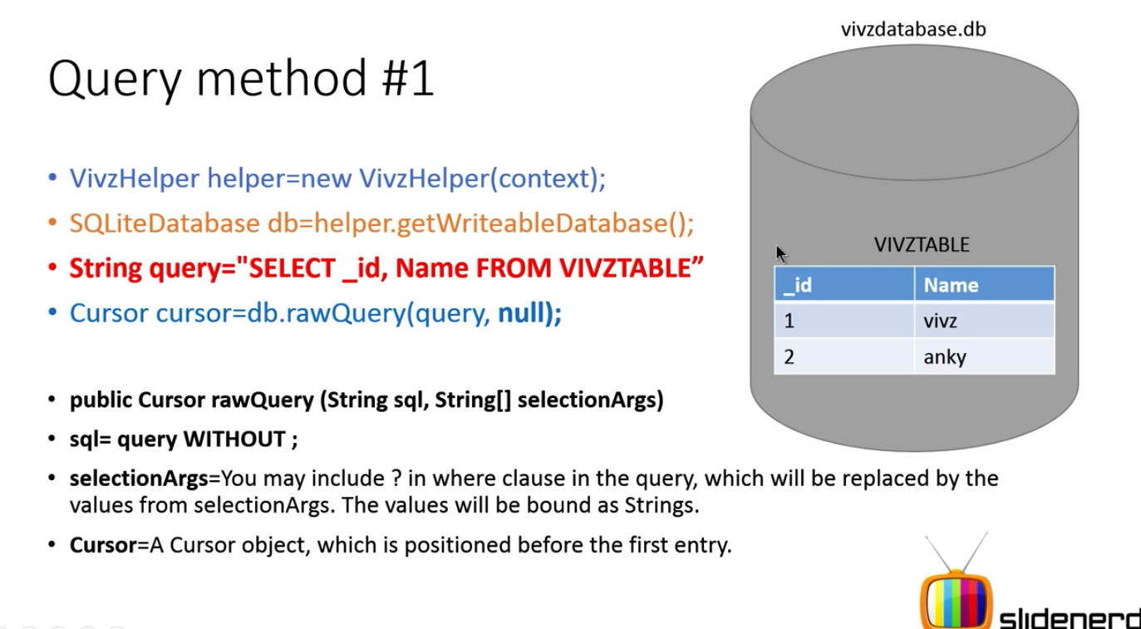

android.database.Cursor

Cursor object is a way for you to navigate from the returned subset of the table

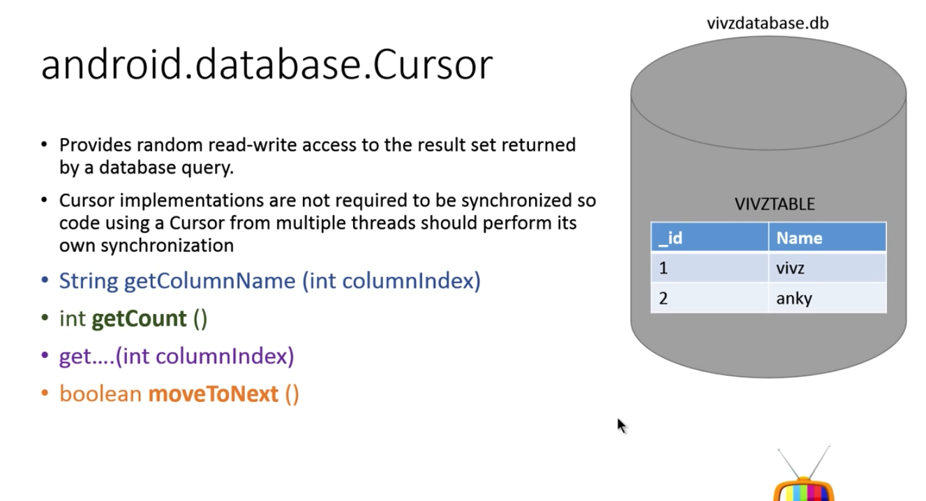

Android recommended way of doing SELECT

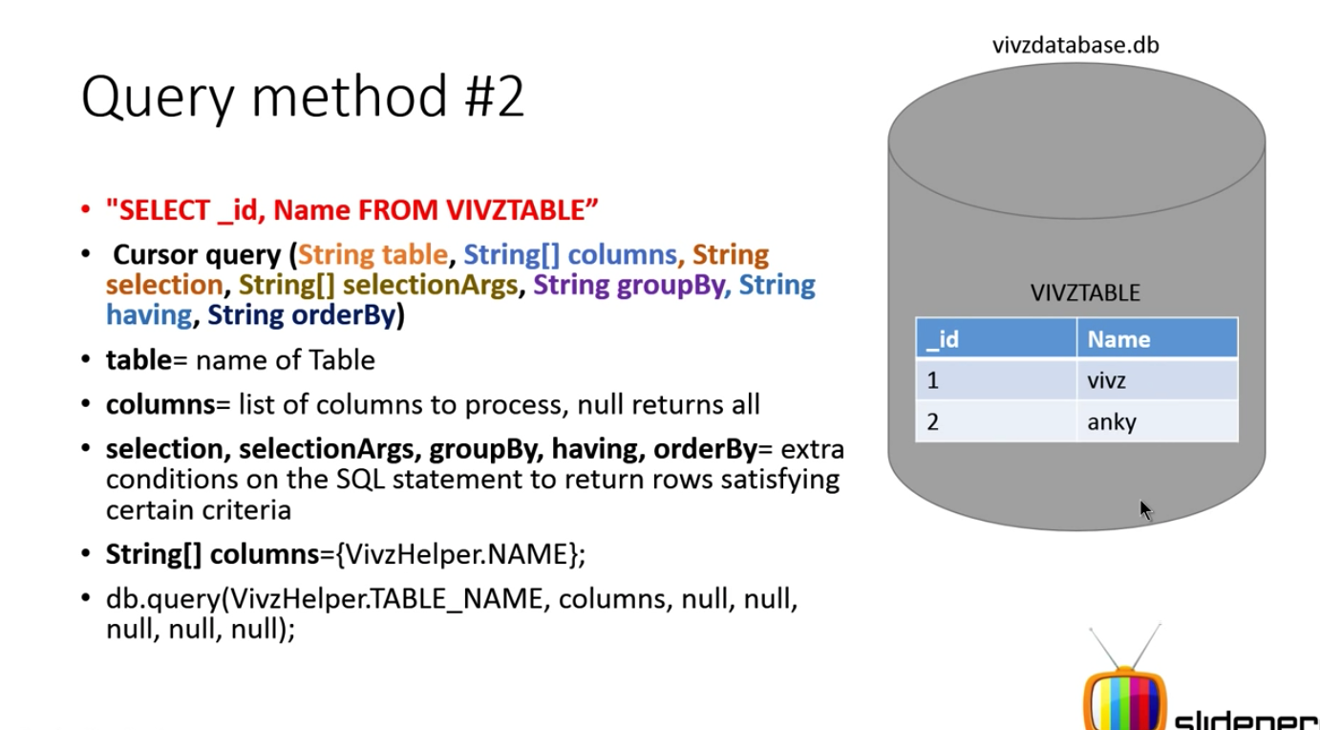

How to process the result

